Exercise #2

ANGULAR EXTRA FEATURES

Aitrich Academy.

© All rights reserved.

* **Introduction**

This document is a specification for the exercise problems for the topic, Angular Extra features. It tests the student's level of knowledge and understanding of the topic.

This document consists of a set of problems that the student needs to solve and submit to the trainer, in the format specified in the Deliverable section of this document.

This exercise is to be performed only after the theory and workshop sessions of the topic; hence the student would have enough knowledge and confidence on the topic. Ideally, the student should be able to solve the problems himself/herself; however, he/she can seek the assistance of the trainer or lab assistant in case he/she is stuck with a specific problem.

* **Objectives**

The objectives of this exercise are to test the student's understanding and knowledge on the topic, and to allow him to re-iterate his understanding by applying that knowledge in a software problem, so that he can use it in the further Programming endeavours.

**Problem 1:**

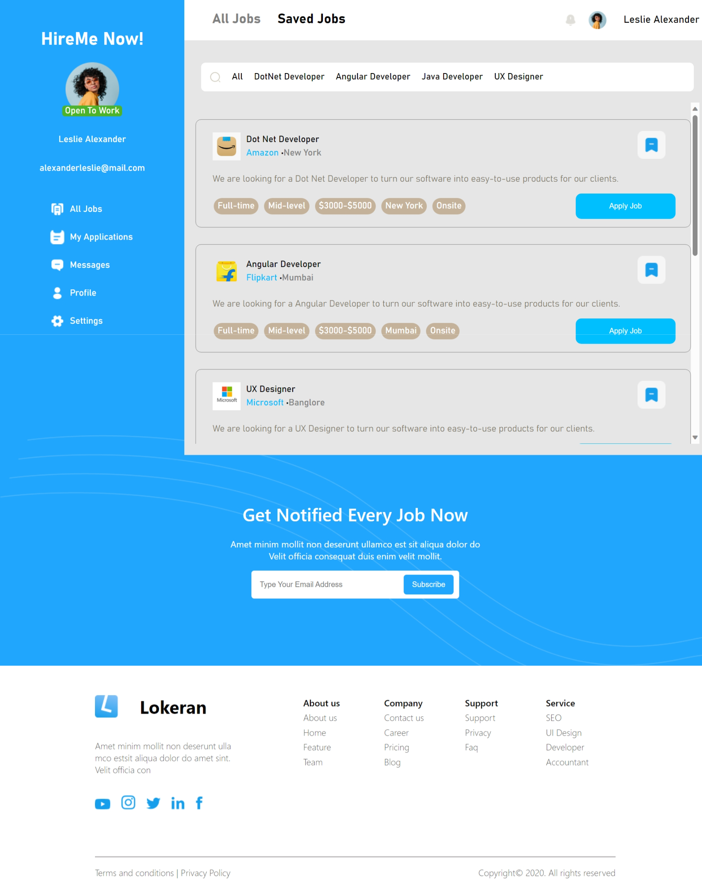

**Features to be developed**

Create an angular application with following components with bind the data using extra features.

1. Create sidebar, header, content, child and footer component.
2. Create an all-job array and Bind data to it. Fields: company logo, company name, job post etc. as we see in the list.
3. Using a filter to display job listings, you can select options such as 'All,' '.NET Developer,' 'Angular Developer,' 'Java Developer,' and 'UX Designer’ in content component.
4. Clicking on 'All' will reveal all job details, while selecting 'Dotnet Developer' will specifically display job details for that role. Choosing any other job title will present the respective job data in the child component.
5. To display a 'Successfully Applied' message in the content component, click the 'Apply Jobs' button inside the card.

**Deliverable**

The entire program should be developed in a single Basic Angular application and delivered as a git hub link.

**Demo**

The student should demonstrate the program to the instructor on a PC, by explaining the features one by one.

**Conclusion**

The completion of this exercise should re-iterate the student's confidence on Angular Extra features. Please make sure you have gained enough confidence to move on.